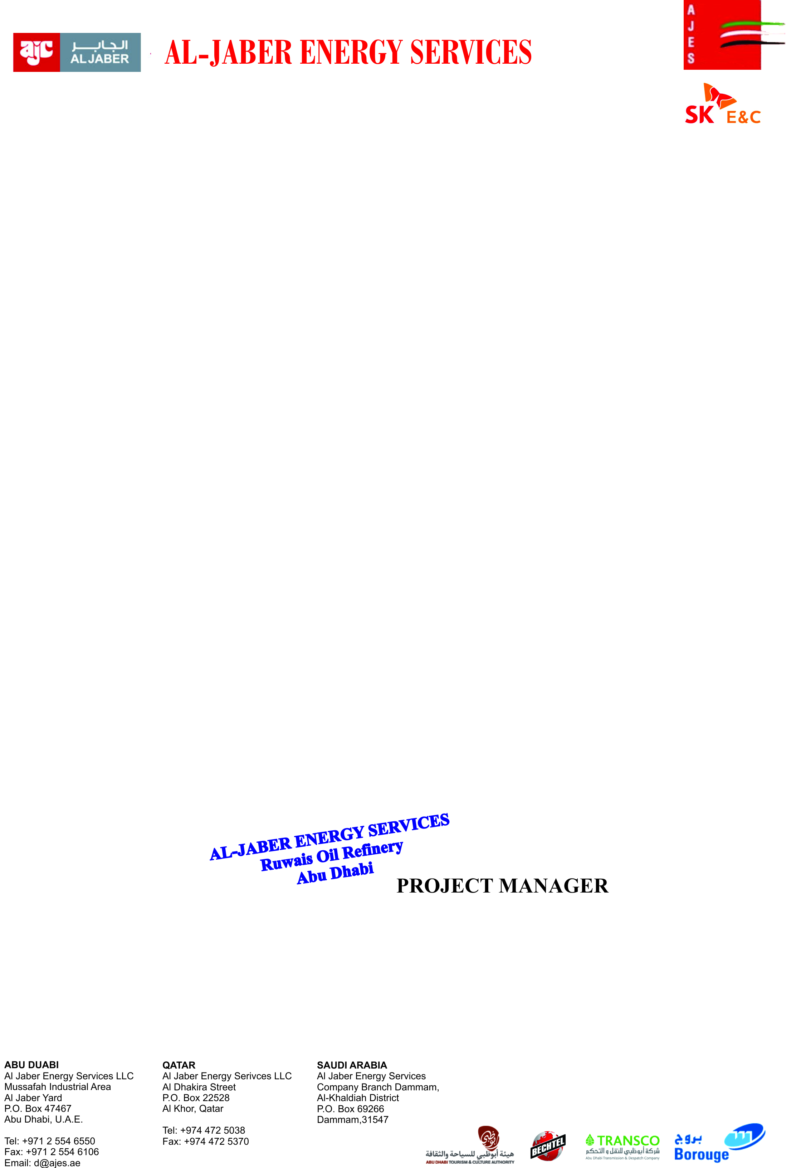

Dated: <To>

**TO WHOM IT MAY CONCERN**

It is certified that Mr. <Name> S/O <fname> has worked with us as a <Designation> at Ruwais Oil Refinery Abu Dhabi from <From> to <To>.

During this period, his services were found satisfactory. We wish him every success in his future life.

